The Sacrament
of Marriage

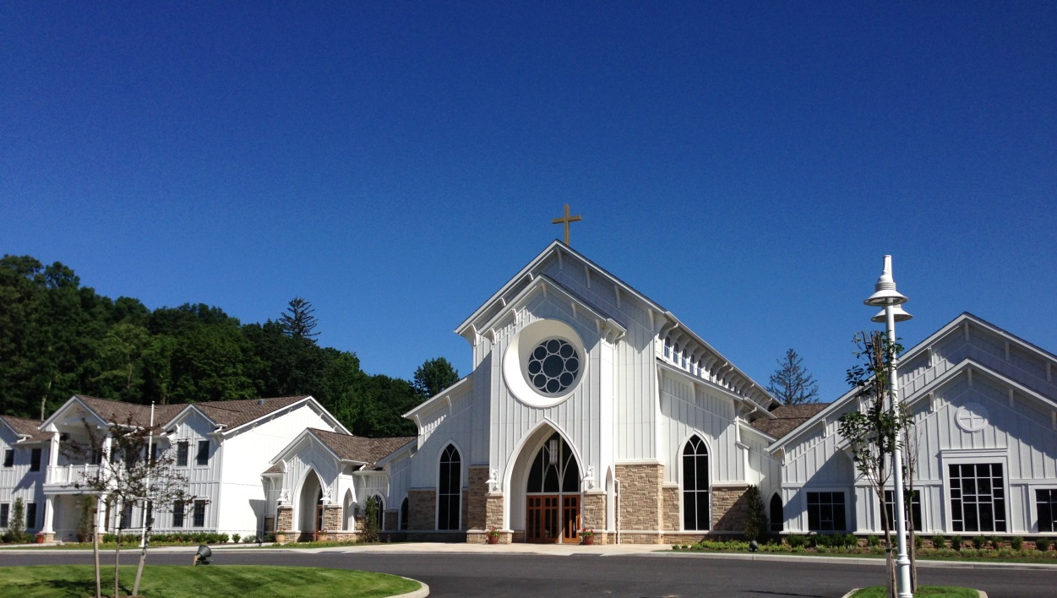

St. Joseph’s Church
95 Plum Brook Road
Somers, New York 10589
www.stjosephsomers.org
(914) 232-2910
(914) 232-2912 (fax)
Father John M. Lagiovane, Pastor
Father Robert Carolan Parochial Vicar
Father Jude Aguwa, Parochial Vicar
Deacon Douglas Borrelli , Deacon Larry Battersby, Sub-Deacon Michel Rabbah, MCR
Vincent Mateo, Director of Sacred Music / Organist
______________________________________________________________________
Dear Friend,

Congratulations on your engagement. Planning your wedding can be one of the most exciting times of your life. We are happy that you have chosen St. Joseph’s Church to be a part of your special day. We want to help you plan a wedding ceremony or wedding mass that is spiritual and sacramental in accordance with the Catholic belief that marriage is a lifelong commitment and that it is a sacrament when it occurs between two baptized Christians. Marriage is both a natural institution and a sacred union. The Church sees marriage as a sign of the unconditional love God has for all people, and a sign of the unity in which all Christians are called to live.

Since planning a wedding can also be one of the most stressful times of your life, we have prepared this information pamphlet to help guide you through the process. In addition, you are receiving a publication called Together for Life, which will also serve as a resource for you as you plan your special day. Remember, we are here to help you. May this time of preparation for the Sacrament of Marriage be filled with every good grace that our Lord desires to give you.

With our prayers, love and blessings,

The Parish Family of St. Joseph’s Church



GENERAL INFORMATION

The Sacrament of Marriage Paperwork Requirements
In preparing for your wedding, you will be asked to provide a number of documents. The list below indicates what the Church needs for its records. You are required to provide those marked with a check.

Recent copy of Baptismal Certificate – This comes from the Church of your Baptism and must be dated within six months of the Wedding date. Bride Groom

Copy of First Communion and Confirmation Certificates Bride Groom

Letter of freedom from your resident Pastor/Announcement of Banns Bride Groom

Letter of Consent from parents (if under the age of 21) Bride Groom

Certificate of Completion of Marriage Preparation Program Bride Groom

Permission / Dispensation (if necessary) Bride Groom

In addition to the documents required by the Church, you will need a New York State marriage license. This may be obtained at any city, town or county clerks’ office in the state of New York. Please call ahead to check with the clerk to determine any civil documents you may need.

St. Joseph’s Church Wedding Ceremony Requirements
The offering for a wedding at St. Joseph’s Church is $ 1,000
Organist ($250.) Cantor ($175.) * Wedding Rehearsal Coordinator ( $125- cash)
Other Instrumentalists ($ as requested)

Other requirements for weddings at St. Joseph’s Church include the following:
- Two floral arrangements in the sanctuary – on the stands provided
- No floral arrangements on the Church pews
- No “Runner” down the main aisle or rose petals
- No rice, confetti, seeds, etc. to be thrown inside or outside the Church
- Flower girls are not permitted to throw rose petals down the aisle as they process in or out of the Church
- Limousine drivers are not permitted to serve champagne on Church property
- Please NO food, drink etc outside the church before or after ceremony

Please check with your priest regarding any other questions you may have.

Wedding Ceremony / Nuptial Mass Planning and Preparation
Your Wedding Ceremony or Mass will be primarily planned by you, using this information pamphlet and the Together for Life booklet provided to you, which contains guidelines for planning Catholic Wedding services. If you choose to celebrate Mass as part of your Wedding Ceremony, the order of liturgical rites would be Liturgy of the Word, Marriage Rite, Liturgy of the Eucharist and Blessing. If you choose to plan your Wedding Ceremony outside of a Mass, the order of liturgical rites would be Liturgy of the Word, Marriage Rite and Blessing. Please be advised that the readings at a Nuptial Mass must be proclaimed by a baptized Catholic.
You will select Scripture Readings, the form of your vows, the General Intercessions / Universal Prayer, and music. You also have the option to include a lighting of the Unity Candle, and/or a presentation of Flowers to the Blessed Mother. You will use the LITURGY PLANNER pages in the Together for Life booklet, to plan your Wedding Ceremony or Mass, and the WEDDING MUSIC PLANNER enclosed to select your music.

Wedding Music
The Sacrament of Marriage and the music selected in a Catholic Wedding should be appropriate for the occasion and the religious nature of the celebration. While many popular love songs have a special meaning to the couple, they are better suited for the reception and not permitted in church.
Musicians serving at your wedding are from St. Joseph’s Church. The parish employs an organist and cantor, and maintains a roster of professional music groups, singers/soloists and instrumentalists. Therefore, outside soloists, groups or musicians are not permitted. In the event any outside musicians are approved, our organist and cantor fees must still be included with the other church wedding fees.

The number of musical selections at your wedding will be determined by the type of ceremony you plan. A Nuptial Mass is a Solemn Mass and includes Holy Communion, whereas a Ceremony does not. For either service, the Responsorial Psalm should be sung rather than recited.
The wedding couple should contact the Director of Sacred Music by email at least three (3) months in advance of the wedding to arrange for all music. At that time, the WEDDING MUSIC PLANNER will be completed in consult with the Director of Sacred Music. Wedding Couple also has the option to simply complete the PDF planner, and E-mail it directly to the Music Office. (This PLANNER has been provided with this pamphlet.) Once your WEDDING MUSIC PLANNER is completed/submitted, review/approval by the Director of Sacred Music and a confirmation acknowledgement E-mail will follow.
Sample wedding music selections are listed on the WEDDING MUSIC PLANNER and sample wedding music audio files are available on the parish website. You can also find audio samples of many of these pieces online as well. These selections are approved by the Parish and by the Music Commission of the Archdiocese of New York. Additional instrumental and vocal selections may also be permitted, provided that the music is sacred.

Wedding Rehearsal
Your wedding rehearsal will be scheduled with your celebrant. Be sure to bring your Marriage License, the completed LITURGY PLANNER, and all church fees with you to this rehearsal.

DATE:______________________________

TIME:____________________

St. Joseph’s Church- Liturgy Planner

The Sacrament of Marriage/ Date ______________
Groom ____________________Bride____________________

Old Testament Readings: pages 16-33 (B1- B9) No.__________

Read by ___________________________

Responsorial Psalm- Sung by Cantor/ N0. __________

New Testament Reading: pages 44- 66 (D 1- D14)
No.______
Read by_____________________________

Nuptial Blessing: pages 102- 106 (M1- M3)
Page 112 (M5)
No._____________________

Flowers to the Blessed Virgin Mary ____________

St. Joseph’s Church WEDDING MUSIC PLANNER—
To be completed in consultation with the Director of Sacred Music.
The WEDDING MUSIC PLANNER must be initialed and sent to Director of Sacred Music at least 1 month prior to the Wedding.
(photo, email, scan, pdf, USmail, etc.)

Wedding Date/Time:
Mass/Ceremony:
Church: St. Joseph’s Church, Somers, New York………………………………
Bride:
Groom:
Celebrant:

Prelude(s):

Bridal Party Entrance:
Bride Entrance: (may be the same as bridal party)

Responsorial Psalm: (sung by soloist)

Offertory : ( nuptial mass only)………………………………………………………………………………………...

Communion: (nuptial mass only)

Gift to the Blessed Mother (option)

Recessional:

Postlude:

Organist/Director of Music:
Vincent Mateo
914- 522- 0066
mateo.stjoesmusic@gmail.com

OFFICE USE ONLY

INITIAL CONTACT: _______________
CONSULT. DATE: ________________
DATE PLANNER REC’D: ___________

Music Fees/Special Requests:
Organist: _______________________
Cantor: _____ ___________________
Guest Vocalist/ Instruments:________________________
__________________________________

Other Options:

Printed Program:___Y/N______________
Unity Candle:______Y/N_____________
Flowers/BVM:_____Y/N_____________
Other/: ___________________________
__________________________________

Please initial / date:

Bride:_______________________

Organist: ____________________

NOTES/
Wedding Party Configuration:_________________________________________________________________________________________________________________________________________________________________________________________________
____________________________
____________________________
____________________________
____________________________

General Notes/Information:
- Fees are due at wedding rehearsal.
Wedding Music in church should be sacred. Broadway and secular love songs should be reserved for your reception. Trust the judgment and suggestions of the organist regarding both the selection of church music and the hiring of additional musicians.
Soloists and additional instrumentalists may be requested (at additional fees per musician.)
Please don't be late for your wedding. Church Musicians maintain tight schedules, especially during busy wedding seasons. There is likely another bride waiting for music right after you.
- If you are printing a program, it must be attached to this form or e-mailed to the organist 2 weeks before the wedding date.
- Unforeseen circumstances or emergencies may require substitute musicians.
Thanks for the opportunity to provide
the church music for your special day.

Wedding Music Selections:
(Track numbers refer to titles below. Audio files are available with wedding prep materials on our parish website, www.stjosephsomers.org, and/or with the Wedding Preparation booklet and information packet available from parish office)

Track 1 | Air on a G String ( J.S. Bach) (P/R) |  | Love Divine, All Loves Excelling (Hyfrydol) (V) (O/C)
Track 2 | Ave Maria (Franz Shubert) (V) (Pr./O/BVM) |  | Marche Royale (Jean-Baptiste Lully) (P/R/PL)
Track 3 | Ave Maria ( Bach/Gounod) (V) (Pr./O/BVM) |  | Meine Seele erhebt den Herren (J.S. Bach) (Pr./O/C)
Track 4 | Bridal Chorus (Wagner) (E) |  | Ode to Joy (Beethoven) (P/R/PL)
Track 5 | Canon in D (Pachelbel) (P) |  | Organ Concerti Variations (Handel) (Pr./P/R/PL)
Track 6 | The Earth is Full (PSALM) (V) (RP) |  | Organ Sonatas - Various Movements (Mendelssohn) (Pr/R/PL)
Track 7 | Faith, Hope, Love (HYMN) (V) (O/C) |  | Panis Angelicus (Franck or Lambillotte) (V) (C)
Track 8 | Jesu, Joy of Man’s Desiring (J.S. Bach) (P/O/C) |  | Prelude to a Te Deum (Charpentier) (Pr./P/R/PL)
Track 9 | Largo (Vivaldi) (Pr./P) |  | Prelude, Fugue and Chaconne in C (Buxtehude) (R/PL)
Track 10 | The Lord is Kind (Haas) (V) (RP) |  | Psalm 150 (Sigfrid Karg-Elert) (R/PL)
Track 11 | Wedding March (Mendelssohn) (R) |  | Rigaudon (Andre Campra) (R/PL)
Track 12 | Now Thank We All Our God (J.S. Bach) (PL) |  | Royal Fireworks Music (Handel) (P/R/PL)
Track 13 | Rondeau (Jean-Joseph Mouret) (P/R/PL) |  | Solemn Processional (Boellman) (P)
Track 14 | Let the Bright Seraphim (Handel) (V) (Pr.) |  | Spring – from the Four Seasons (Vivaldi) (Pr/P/R)
Track 15 | Sheep May Safely Graze (J.S. Bach) (Pr./O/C) |  | Suite Gothique (Boellman) (Pr./R/PL)
Track 16 | Arrival of the Queen of Sheba (Handel) (P) |  | The Emperor’s Fanfare (A. Soler) (P/R/PL)
Track 17 | Toccata, Symphony No. 5 (Widor) (R/PL) |  | Trumpet Tune in D Major (Purcell) (P/R/PL)
Track 18 | Trumpet Voluntary in D Major (Clarke) (P/R/PL) |  | Trumpet Tune in D Major (Johnson) (P/R/PL)
Track 19 | Hornpipe (Handel) (P/R/PL) |  | Tuba Tune (C.S. Lang) (P/R/)PL)
 |  |  | Water Music – Various Movements (Handel) (Pr/P/R/PL)
 | ADDITIONAL MUSIC OPTIONS/SELECTIONS:
 | Allegro Vivace (Handel) (P/R/PL)
 | Ave Verum (Mozart) (V) (Pr./O/C) |  | (V) = VOCAL SELECTION
 | Chaconne (Couperin) (Pr./P/R/PL)
 | Come Down, O Love Divine (Down Ampney) (V) O/C)
 | Fanfare (J Lemmens) (R/PL)
 | Festival Prelude (Charpentier) (R/PL)
 | Festival Voluntary (Peeters) (Pr./R/PL)
 | God is Love (Abbotts Leigh) (V) (O/C)
 | God Who Created Hearts to Love (V) (O/C)
 | Hear Us Now Our God and Father (Hyfrydol) (V) (O/C)
 | In dir ist Freude (J. S. Bach) (Pr./R/PL)

Notes:

Suggested best/most appropriate places at your mass or ceremony to use above selections:
Pr=Prelude; P=Processional; O=Offertory; C=Communion; R=Recessional; PL=Postlude; BVM=Gift to Blessed Mother.
Almost any vocal can be used at unity candle or after exchange of rings.

--------------------------------------------------------------------------------------------------------------------------
Vincent Mateo , Director of Sacred Music
914- 522- 0066
E-mail: mateo.stjoesmusic@gmail.com

